

A Project Report On

**Placement Management System**

**By :**

**Chetana G. Wawle**

**Nikita M. Raghuwanshi**

**Mansi K. Bhandari**

**Aparna S. Murkut**

**B.E**

**Batch:** 2021 – 5733

**Center: Pune**

Under the Guidance of,

**Jayant V.**

**Technical Trainer**

**EduBridge**

(School of coding)

* **Introduction:-**

Our project explains about the Placement Management System. This project mainly explains how student can register themselves on website and apply for the companies drive. User can add admin, student, placement, college, certificate. Our Project Includes **Modules:-**

* Admin Module
* User Module
* Student Module

I have developed this Application in **Java, JSP, Servlets, Hibernate and MySQL.** It’s a web-based projects so I have used **HTML, CSS, JavaScript**.

The main feature of the project is to make placement management system so that students can apply for the companies and get a job. You can access this website from anywhere and everywhere.

In Admin module, admin can add the admin, student, placement, college, certificate, user and after that we can see the list of admin, student, placement, colleges, certificates, user.

In User module, user can add the student, placement and certificates and after that we can see the list of students, placements, certificates.

* **Software Requirements:-**
* **Back end:** Eclipse neon.3
* **Front end:** Sublime Text
* **Database**: MySQL workbench 8.0.23CE.
* **Middleware/Server:** Apache Tomcat v8.5. IDE: Eclipse IDE for Java EE Developers
* **Browser:** Best result on Google Chrome
* **Operating System:** Window 7

# Database:-

* create database userdemo;
* use userdemo;

# Screenshots:-

1. **Home Page:**

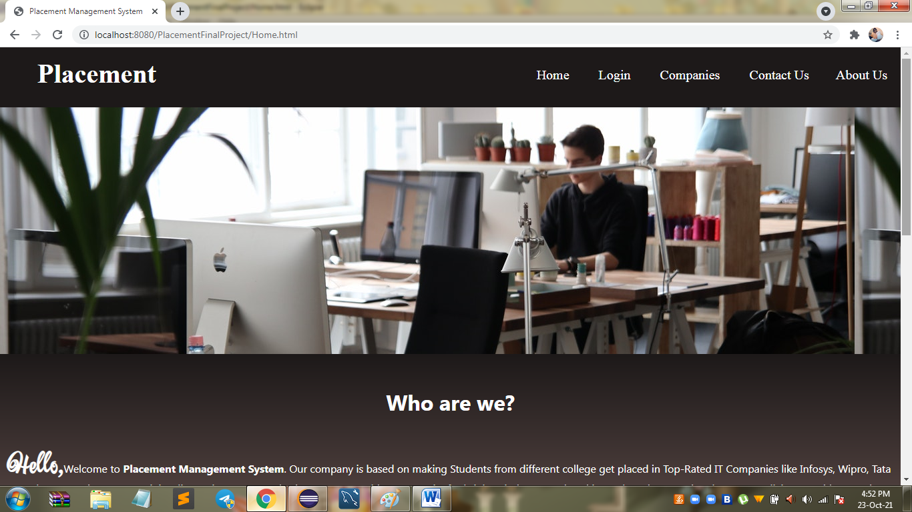

1. **Login Page:**

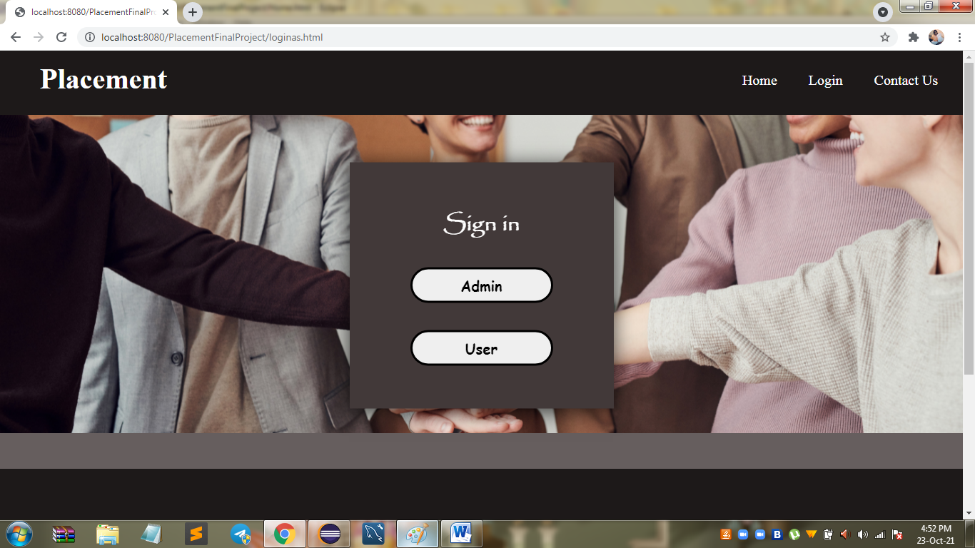

1. **Companies Page:**

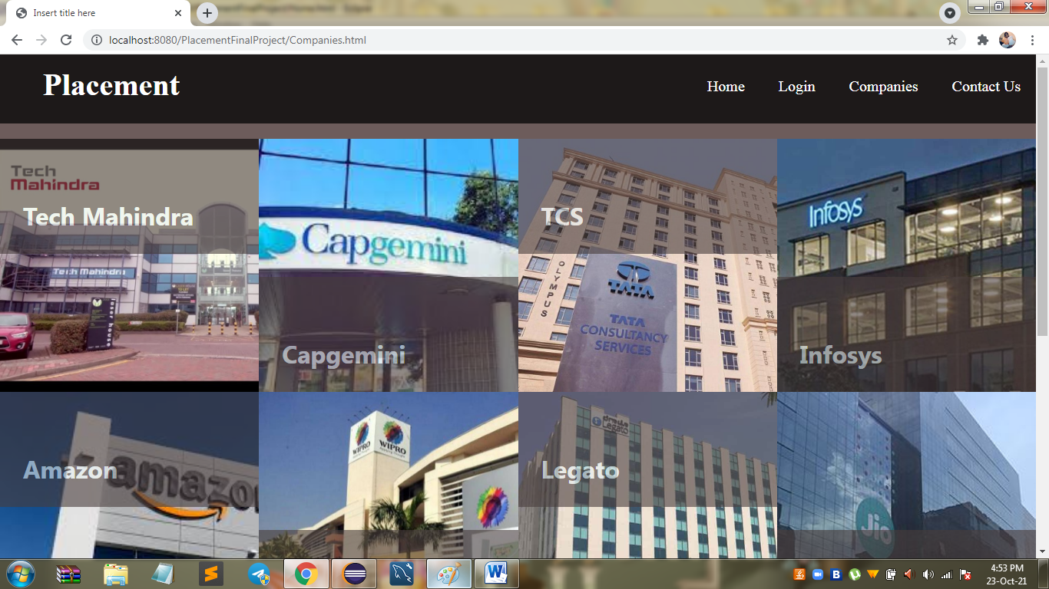

1. **About Us Page:**

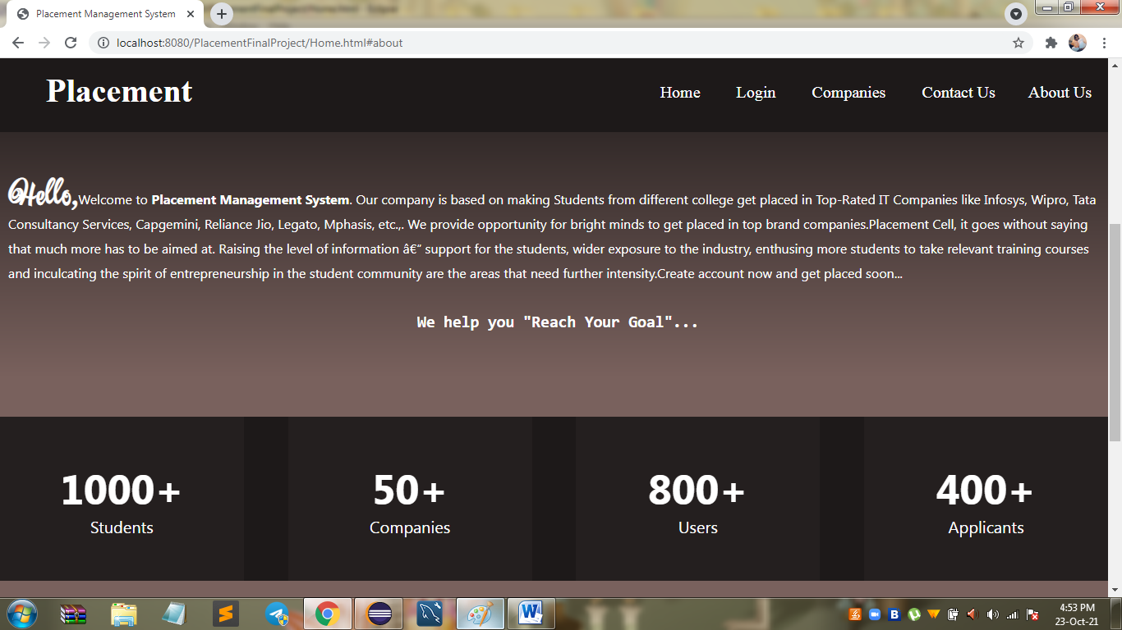

1. **Contact Us Page:**

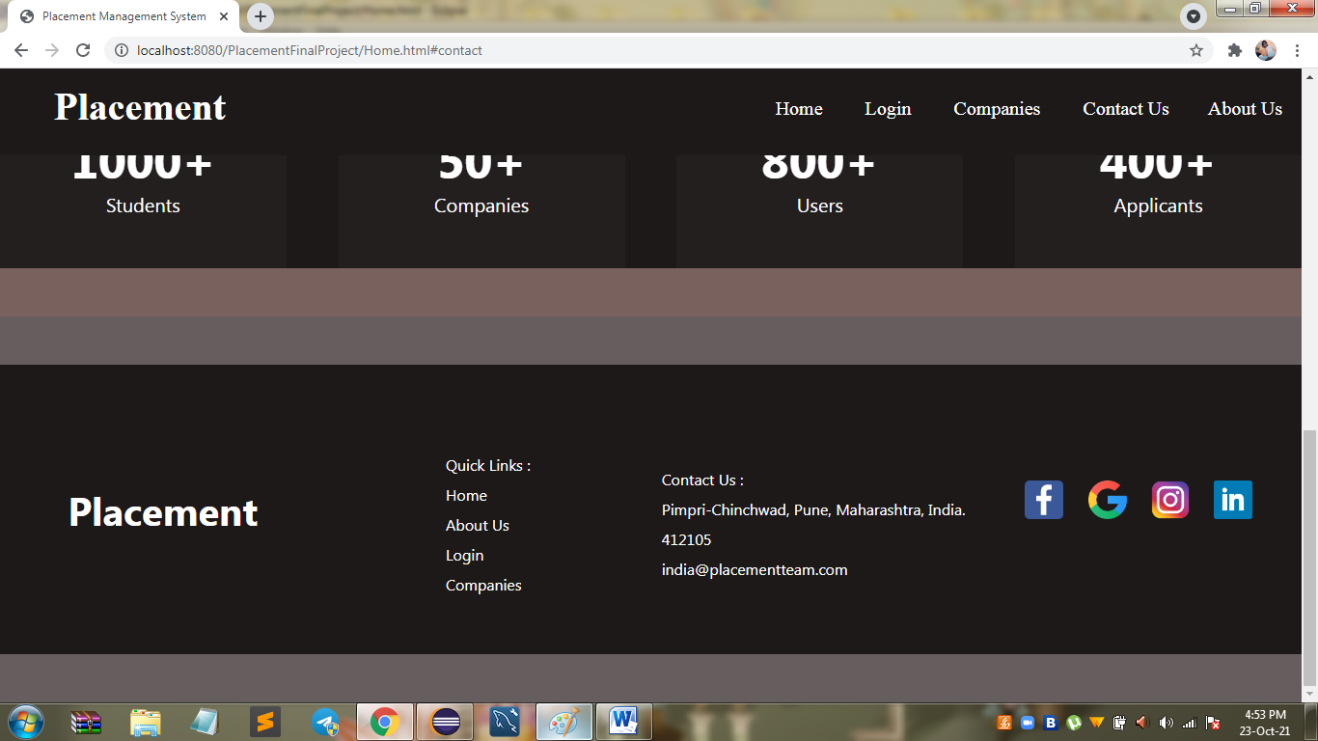

1. **Admin Login Page:**

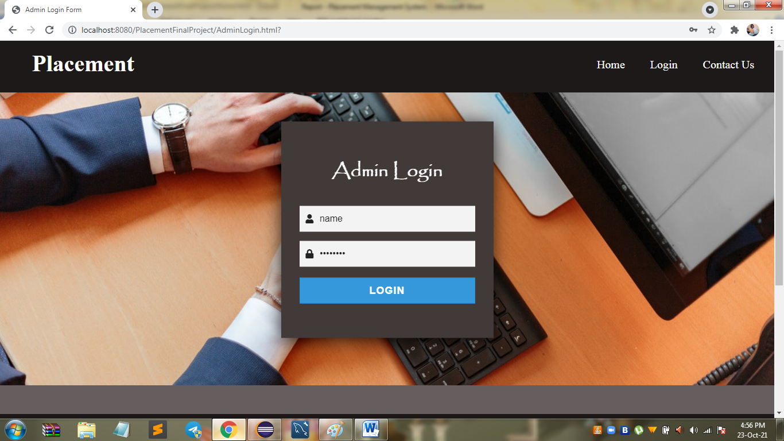

1. **User Login Page:**

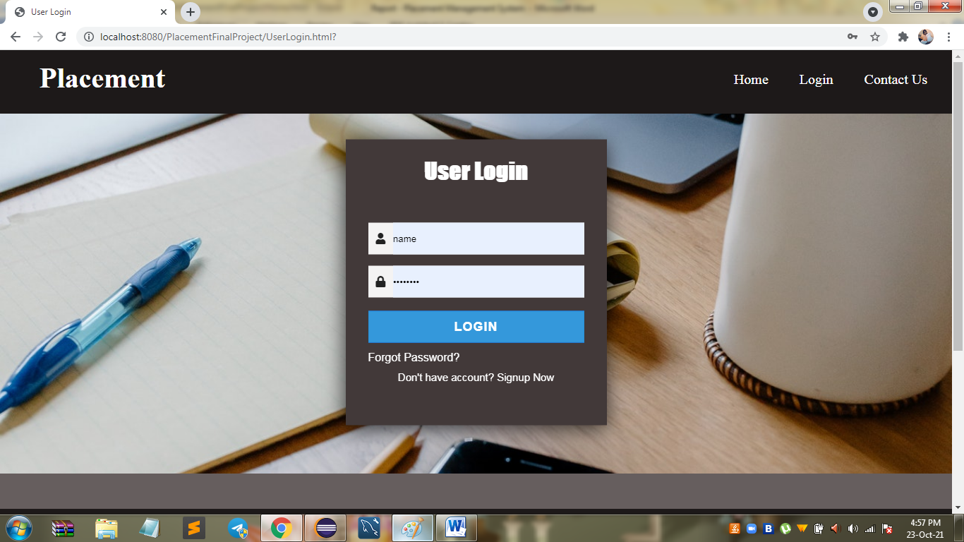

1. **Admin Dashboard Page:**

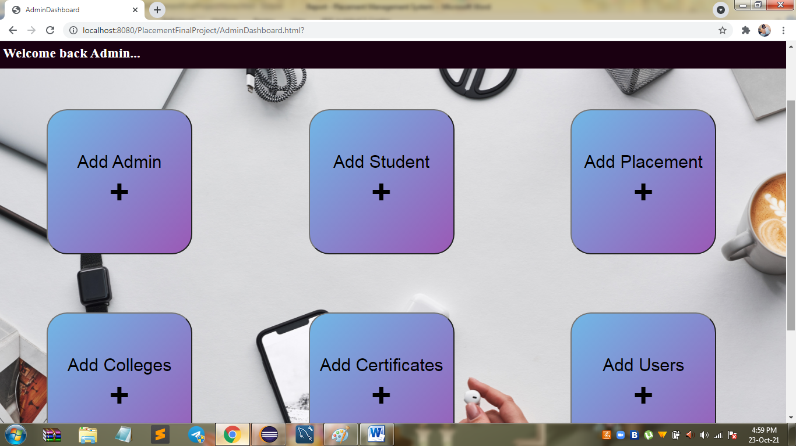

1. **User Dashboard Page:**

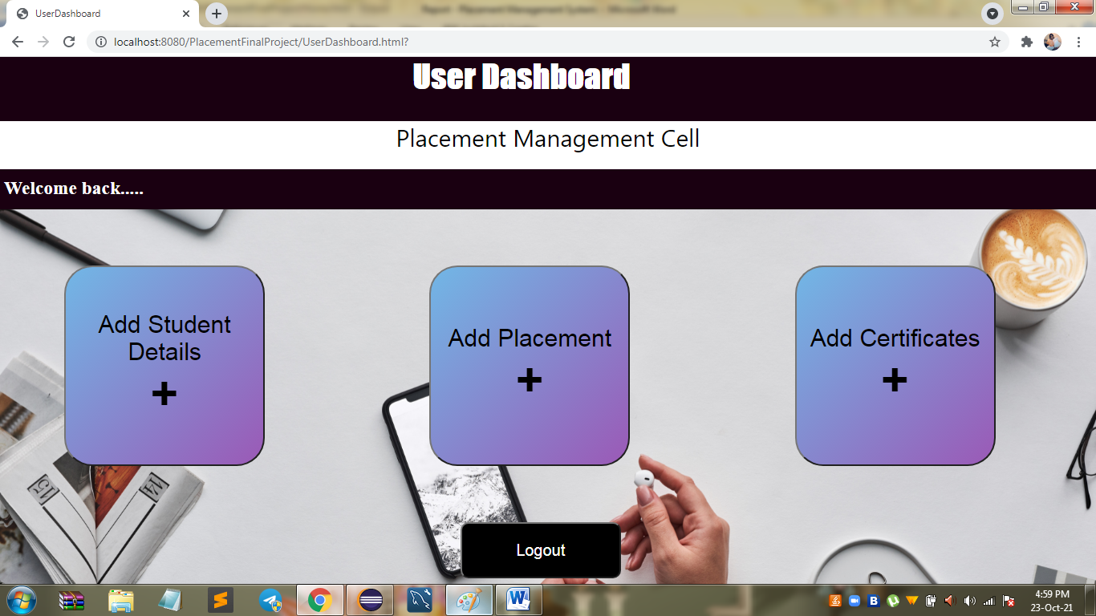

1. **Add Admin Page:**

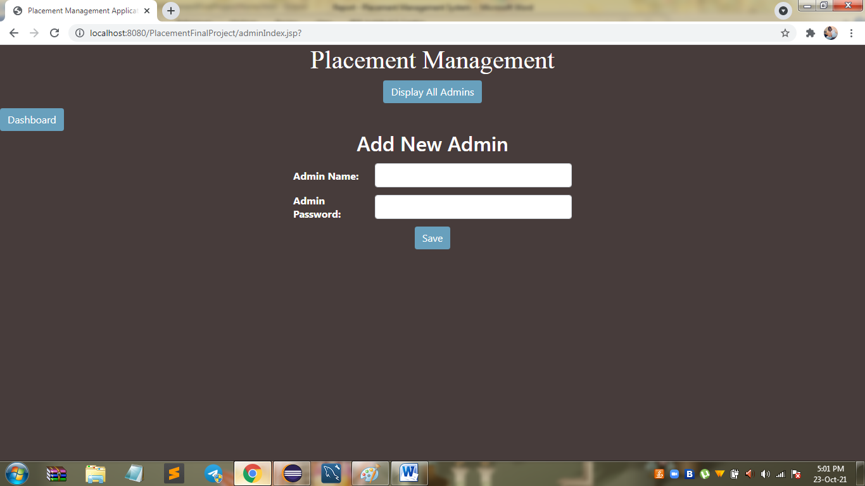

1. **Add Student Page:**

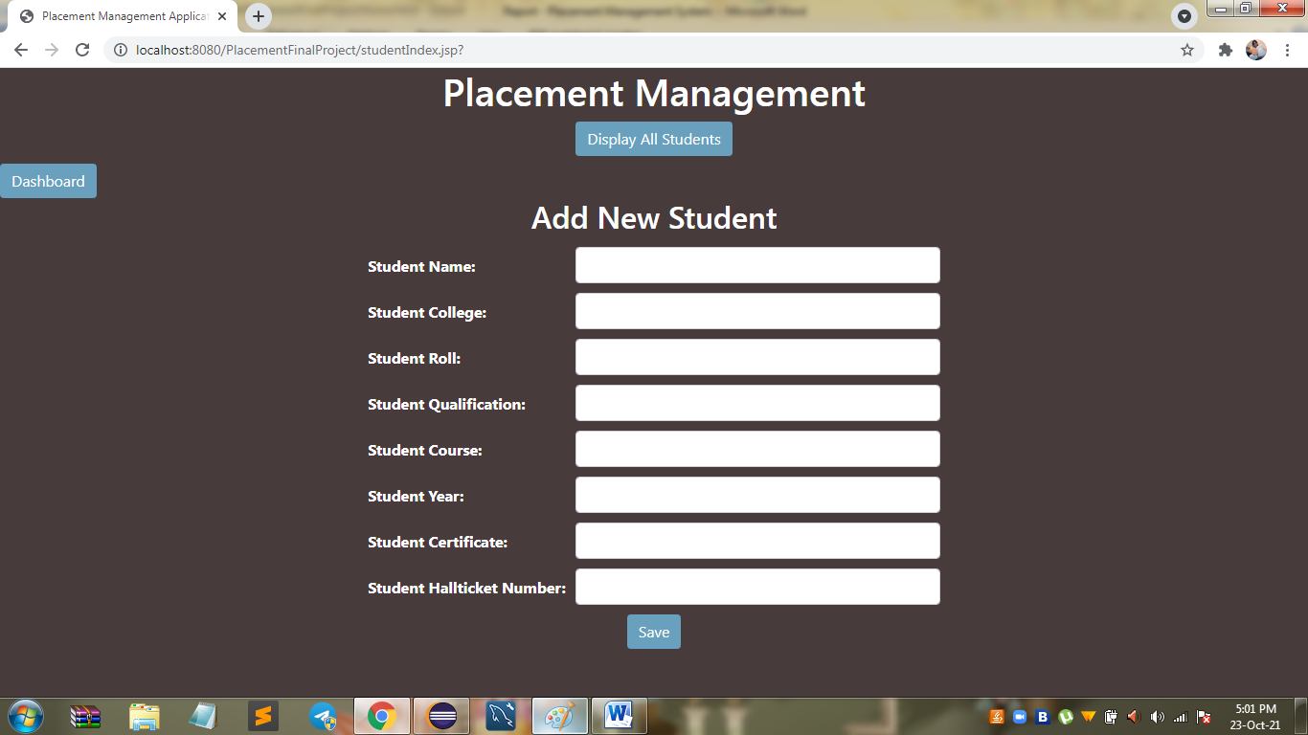

1. **Add Placement Page:**

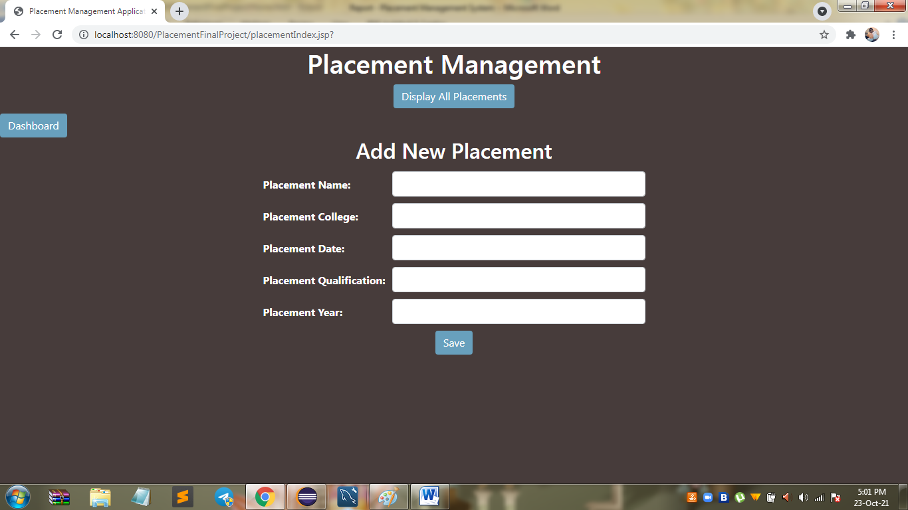

1. **Add College Page:**

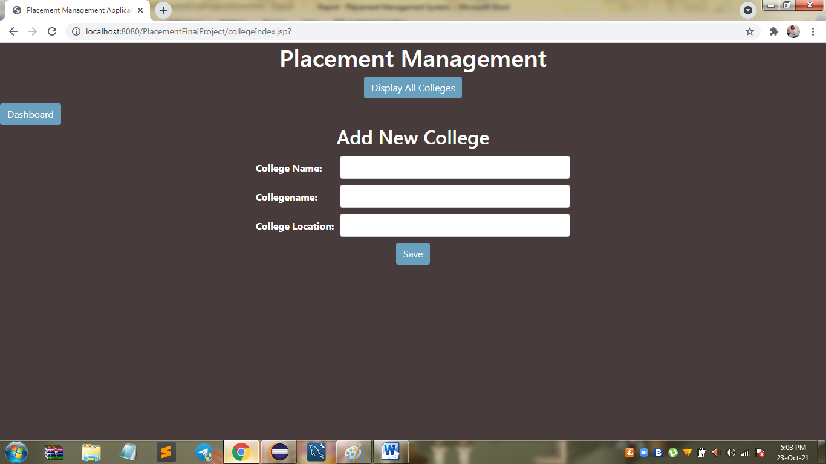

1. **Add Certificate Page:**

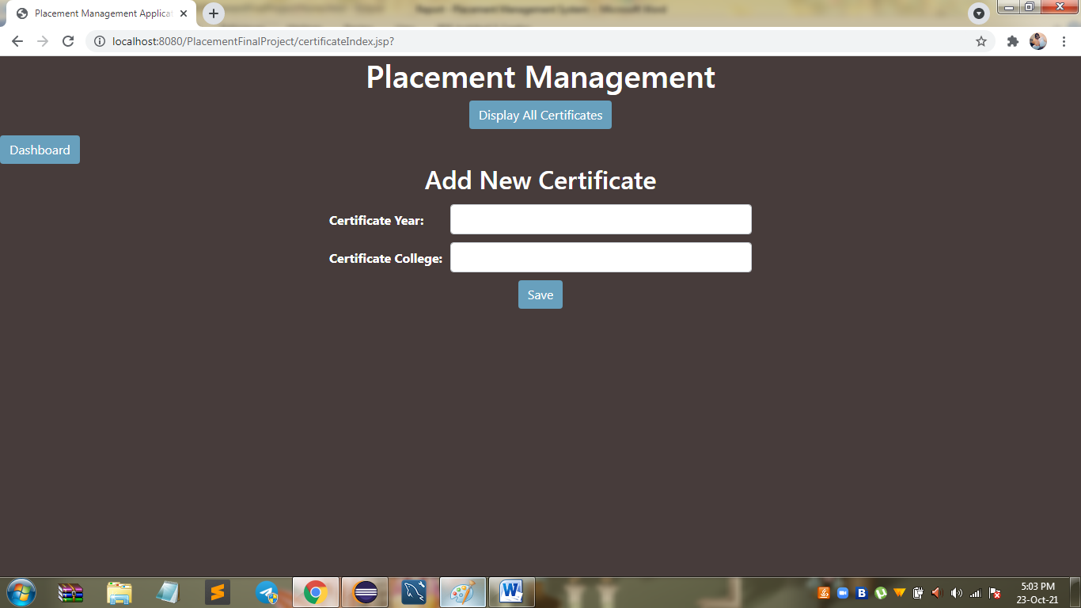

1. **Page:**

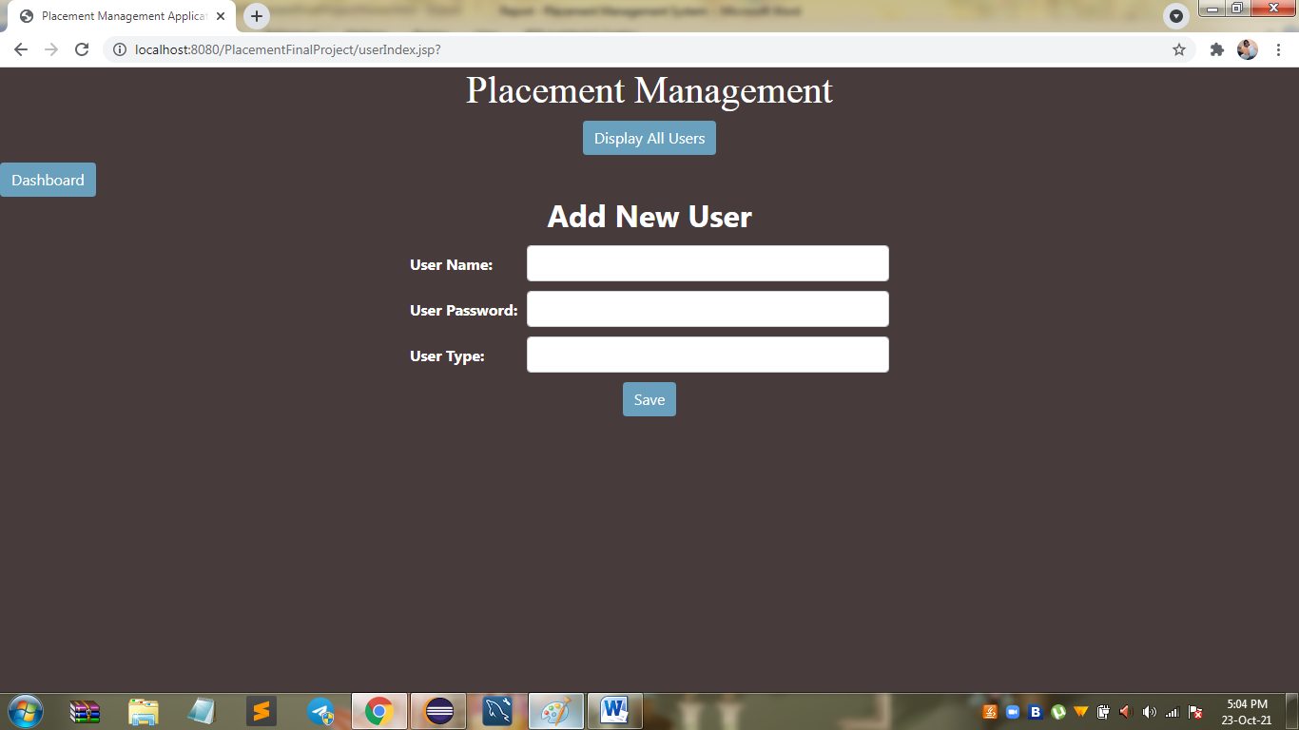

**Thank you**